Advantages of Classification Trees
- Interpretability and Simplicity
Classification trees are easy to understand and interpret, even for non-technical stakeholders. Their tree-like structure, with decision rules leading to outcomes, makes them transparent and useful for presenting results to decision-makers (Wikipedia, 2025).
- Handling of Diverse Data Types
They can process both numerical and categorical variables without requiring complex data transformations, which makes them highly versatile for real-world datasets (DataCamp, n.d.).
- Modeling Non-linear Relationships
Unlike linear models, classification trees capture complex, non-linear relationships between features and outcomes, which improves their applicability across a wide range of domains (GeeksforGeeks, n.d.).
- Flexibility in Marketing and Business Applications
They are particularly effective in marketing tasks such as customer segmentation, churn prediction, and purchase behavior analysis, where categories (e.g., “churn/not churn”) are more meaningful than continuous predictions (Analytics Vidhya, 2021).
- No Need for Assumptions About Data Distribution
Classification trees do not assume linearity, normality, or homoscedasticity in the data, making them robust when applied to diverse datasets (Wikipedia, 2025).
Why This Analysis Matters for Marketers
The Telco Customer Churn dataset represents a common business problem: identifying which customers are likely to leave (churn) so that marketing teams can take action.
Using a Classification Tree helps marketers because:
- Customer Segmentation: The tree splits customers based on key attributes (e.g., contract type, tenure, monthly charges), creating natural segments.
- Actionable Insights: Each branch shows decision rules that help marketing teams target the right customers with retention offers.
- Churn Reduction Campaigns: By predicting churn, companies can design proactive campaigns (discounts, loyalty programs, better service bundles) to retain high-risk customers.
- Resource Allocation: Marketing budgets can be focused on customers with the highest probability of leaving, improving ROI.
In short, classification trees transform raw customer data into clear decision rules, empowering marketers to take data-driven actions that improve customer lifetime value and reduce churn.
How Marketing Teams Can Use This Output for Churn Campaigns
The classification tree analysis not only predicts churn but also highlights the top factors influencing customer decisions (e.g., contract type, tenure, monthly charges).
Marketing teams can apply these insights in the following ways:
- Targeted Retention Offers: Customers flagged as high-risk can be offered discounts, flexible contracts, or loyalty rewards.
- Proactive Engagement: High-value customers nearing the end of a short-term contract can be contacted early with personalized renewal campaigns.
- Service Improvement: If features like tech support or internet service type are strong churn predictors, marketers can collaborate with operations to enhance these services.
- Budget Optimization: Instead of broad retention campaigns, resources can be focused on the most at-risk segments, maximizing ROI.
In summary, the tree provides actionable rules that connect data science with marketing strategy, enabling churn reduction campaigns that are smarter, more efficient, and customer-focused.
Disadvantages of Classification Trees
While classification trees are powerful and easy to interpret, they also come with several limitations:
- Overfitting
  - Trees can become overly complex, capturing noise in the data rather than true patterns.
  - This reduces their ability to generalize to unseen data (Hastie, Tibshirani, & Friedman, 2009).
- Instability
  - Small changes in the dataset (e.g., adding or removing a few records) can lead to a completely different tree structure, making results less reliable (Loh, 2014).
- Bias Toward Features with Many Levels
  - Features with more categories (e.g., ZIP codes) are more likely to be chosen for splits, even if they are not the most informative (Breiman et al., 1984).
- Limited Predictive Power (Compared to Ensembles)
  - A single classification tree often performs worse than ensemble methods such as Random Forests or Gradient Boosting, which reduce variance and improve accuracy (Lantz, 2019).
- Difficulty with Linear Relationships
  - Trees split data into rectangular regions, which makes them less effective at modeling smooth or linear boundaries between classes (Han, Kamber, & Pei, 2011).

Equations: How a Classification Tree Works
- Node Impurity
At each node, the algorithm selects a split that reduces impurity. Common measures:
Gini Index:
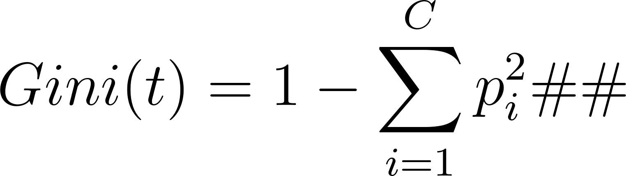
- 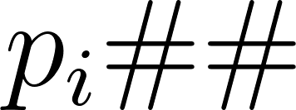 = proportion of class  in node 
-  = total number of classes
- Lower Gini → purer node
Entropy (Information Gain):
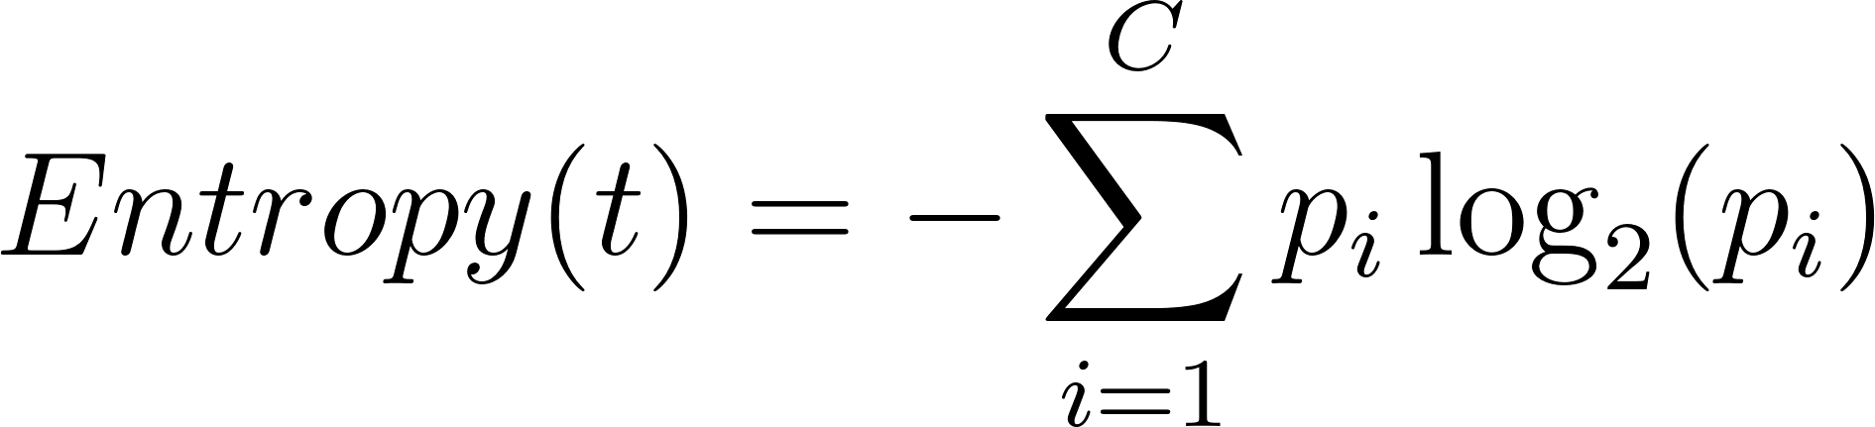
- Measures the disorder in a node.
- Splits are chosen to maximize information gain:
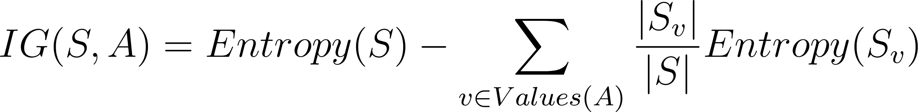
- S = current dataset
- A = feature used for splitting
- ​ = subset of  where feature  has value 
- Decision Rule / Prediction at Leaf Node
After building the tree, a leaf node assigns a class based on majority voting:
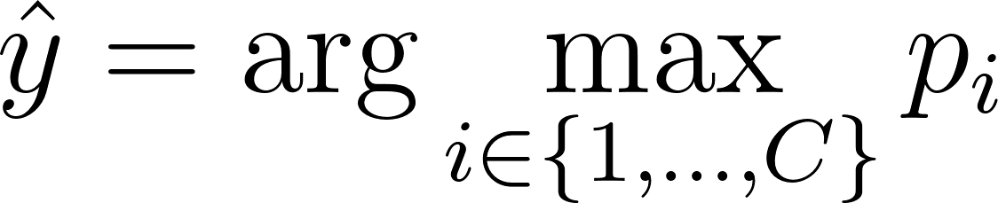
-  = predicted class
-  = proportion of class iii in the leaf node
- Tree Growth (Recursive Partitioning)
The tree is grown recursively by splitting nodes:
-  = candidate feature
-  = threshold value for the split
-  = resulting child nodes
-  = Gini or Entropy
The algorithm stops splitting when:
- Maximum depth is reached, or
- Node is pure (), or
- Minimum samples per leaf is reached

Summary
- Classification trees split data recursively based on features to minimize impurity.
- Leaves predict the class via majority vote.
- Impurity measures (Gini or Entropy) guide the best splits.

Features of Classification Trees
- Handles Both Numerical and Categorical Data
  - Can split on continuous features (e.g., monthly spend) or categorical features (e.g., contract type) without special encoding.
- Non-Parametric / No Distribution Assumptions
  - Does not assume linearity, normality, or homoscedasticity in the data.
- Handles Missing Values
  - Some implementations (e.g., CART, C4.5) can handle missing values either by surrogate splits or by ignoring missing observations at a node.
- Interpretable and Visualizable
  - Produces a tree structure that is easy to understand for non-technical stakeholders.
  - Decision rules from the tree can be expressed in “if-then” statements.
- Automatic Feature Selection
  - Splitting criteria prioritize the most informative features at each node, effectively performing feature selection.
- Flexible and Robust
  - Can model complex, non-linear relationships and interactions between variables.
  - Can be used for classification tasks with multiple classes.
- Supports Ensemble Methods
  - Works as a base learner in ensemble techniques like Random Forests and Gradient Boosting, which improve accuracy and reduce overfitting.

Optional Note for Marketing Context
- Classification trees are particularly useful in customer segmentation, churn prediction, and targeted marketing, because the features selected by the tree naturally highlight the most important factors driving behavior.

Guide: Inputs and Outputs of Classification Trees

Inputs
- Training Dataset
  - Independent variables (features/predictors)
    - Can be numerical (e.g., income, tenure, monthly charges)
    - Or categorical (e.g., gender, contract type, payment method)
  - Dependent variable (target/class)
    - Must be categorical (e.g., churn = Yes/No; customer type = High/Low value)
- Hyperparameters (model configuration)
  - max_depth: maximum levels of the tree
  - min_samples_split: minimum samples required to split a node
  - criterion: measure of impurity (e.g., Gini, Entropy)
  - min_samples_leaf: minimum samples per leaf node
- Splitting Criteria
  - Gini Index
  - Entropy / Information Gain

Outputs
- Decision Tree Model
  - A tree structure of decision rules (e.g., “If contract = month-to-month and tenure < 12 → High churn risk”).
  - Can be visualized for interpretation.
- Predictions
  - For new/unseen data, the model predicts the class label.
  - Example: Churn = Yes or Churn = No.
- Class Probabilities
  - The proportion of samples per class at the leaf node.
  - Example: {Yes: 0.8, No: 0.2} → predicted class is Yes with 80% probability.
- Performance Metrics
  - Accuracy, Precision, Recall, F1-score, ROC-AUC (depending on evaluation).
- Feature Importance
  - Ranking of features based on their contribution to splits and overall predictive power.

Hyperparameters of Classification Trees
- criterion
  - Function to measure the quality of a split.
  - Options:
    - "gini" → Gini Impurity
    - "entropy" → Information Gain (Shannon entropy)
    - "log_loss" → Logarithmic loss (scikit-learn 1.1+)
- max_depth
  - Maximum depth of the tree.
  - Controls model complexity and prevents overfitting.
- min_samples_split
  - Minimum number of samples required to split a node.
  - Larger values → simpler tree, less overfitting.
- min_samples_leaf
  - Minimum number of samples required at a leaf node.
  - Ensures leaf nodes are not too specific.
- max_features
  - Number of features to consider when looking for the best split.
  - Options: integer, float, "sqrt", "log2", or None.
- splitter
  - Strategy used to choose the split at each node.
  - Options: "best" (default) or "random".
- max_leaf_nodes
  - Maximum number of leaf nodes.
  - Prunes the tree by limiting growth.
- min_impurity_decrease
  - A node will be split only if the impurity decrease is greater than this threshold.
- class_weight
  - Assigns weights to classes (useful for imbalanced datasets).
  - Options: None, "balanced", or a dictionary.
- ccp_alpha (Cost-Complexity Pruning)
  - Complexity parameter used for Minimal Cost-Complexity Pruning.
  - Larger values prune more aggressively.
GridSearchCV vs RandomizedSearchCV
When tuning hyperparameters for classification trees (or any machine learning model), two common strategies are:

1. GridSearchCV
- How it works: Tests all possible combinations of hyperparameters you define.
- Pros: Exhaustive and guarantees finding the best parameter set within the grid.
- Cons: Computationally expensive (slow) when the grid is large or the dataset is big.
- Best for:
  - Small to medium datasets
  - When you want full control over specific parameter values

2. RandomizedSearchCV
- How it works: Randomly samples a fixed number (n_iter) of parameter combinations from predefined distributions.
- Pros: Much faster; covers the search space without needing every combination.
- Cons: May miss the exact "best" combination, but usually finds a very good one.
- Best for:
  - Large datasets
  - When computation time is limited
  - Early-stage exploration of hyperparameter space
Rule of Thumb for Marketers and Data Teams
- Use RandomizedSearchCV first to quickly find a promising parameter region.
- Then refine with GridSearchCV on a smaller, focused grid around those values.
This hybrid approach balances efficiency with accuracy and is especially practical for churn prediction or purchase modeling where datasets can be large.

Illustrations: How Classification Trees Work

1. Conceptual Flowchart
A simple diagram showing the process:
- Input data → Splitting based on features → Decision rules → Leaf prediction (class).
📌 This matches the earlier “splits → impurity → leaf prediction” diagram you requested.
Reference: Han, J., Pei, J., & Kamber, M. (2011). Data mining: Concepts and techniques (3rd ed.). Elsevier.

2. Example Classification Tree
Visualize a real tree from the Telco Churn dataset:
- Root node splits on tenure (e.g., > 12 months vs. ≤ 12 months).
- Branches split further on features like MonthlyCharges or Contract type.
- Leaves predict Churn = Yes/No.
Reference: Hastie, T., Tibshirani, R., & Friedman, J. (2009). The elements of statistical learning: Data mining, inference, and prediction (2nd ed.). Springer.

3. Impurity Reduction Graph
A small plot of Gini Index / Entropy vs. Node Depth, showing how impurity decreases as splits occur.
- Useful to visually explain why trees split where they do.
Reference: Breiman, L., Friedman, J. H., Olshen, R. A., & Stone, C. J. (1984). Classification and regression trees. Chapman & Hall/CRC.

4. Feature Importance Bar Chart
Rank the most influential variables for churn prediction:
- E.g., Contract, MonthlyCharges, tenure.
- Helps marketers see what drives churn.
Already part of your Jupyter notebook can be exported as a figure.

5. Performance Metrics Visualization
Side-by-side bar plots or confusion matrix showing model performance:
- Accuracy, Precision, Recall, F1.
- ROC curve (Yes vs No churn).
This connects the mathematics → visuals → marketing application.
Reference: Provost, F., & Fawcett, T. (2013). Data science for business: What you need to know about data mining and data-analytic thinking. O’Reilly Media.
Journal Article Reference:
Ocal, N., Ercan, M. K., & Kadioglu, E. (2016). Predicting Financial Failure Using Decision Tree Algorithms: An Empirical Test on the Manufacturing Industry at Borsa Istanbul. International Journal of Economics and Finance, 7(7), 189-199. CCSE

References (APA 7th edition)
- Analytics Vidhya. (2021, August). Understanding the decision tree algorithm. Analytics Vidhya. https://www.analyticsvidhya.com/blog/2021/08/decision-tree-algorithm/
- Breiman, L., Friedman, J. H., Olshen, R. A., & Stone, C. J. (1984). Classification and regression trees. Belmont, CA: Wadsworth International Group.
- DataCamp. (n.d.). Decision tree classification tutorial using scikit-learn. DataCamp. https://www.datacamp.com/tutorial/decision-tree-classification-python
- GeeksforGeeks. (n.d.). Decision tree in machine learning. GeeksforGeeks. https://www.geeksforgeeks.org/machine-learning/decision-tree/
- Han, J., Kamber, M., & Pei, J. (2011). Data mining: Concepts and techniques (3rd ed.). Elsevier.
- Hastie, T., Tibshirani, R., & Friedman, J. (2009). The elements of statistical learning: Data mining, inference, and prediction (2nd ed.). Springer.
- Lantz, B. (2019). Machine learning with R: Expert techniques for predictive modeling (3rd ed.). Packt Publishing Ltd.
- Loh, W. Y. (2014). Fifty years of classification and regression trees. International Statistical Review, 82(3), 329–348. https://doi.org/10.1111/insr.12016
- Wikipedia contributors. (2025, September 14). Decision tree learning. In Wikipedia. https://en.wikipedia.org/wiki/Decision_tree_learning

